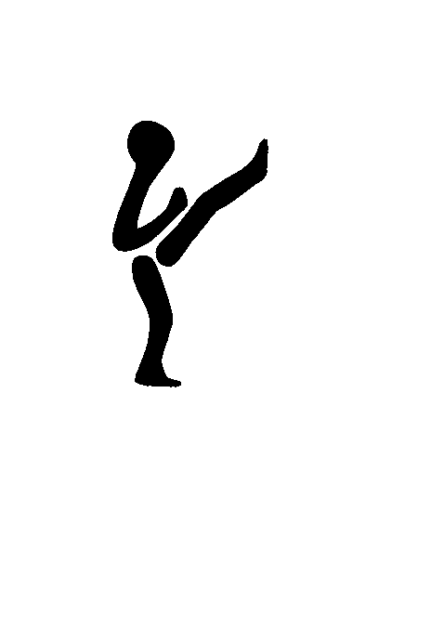
BS Cup
- It starts here
Medical and acceptance note

Event date: ___________ Name of participant: ____________________________________
Do you use glasses or contact lenses? No Yes glasses Yes Contact Lenses
If you use medicine for: (Write medicine, dosage, etc. on the back of this paper).
Diabetes (diabetes) No Yes
Allergy No Yes
Asthma No Yes
Epilepsy No Yes
Cardiovascular diseases No Yes
Do you use medicine in general? No Yes
Have you previously been unconscious? No Yes Date: __________________
Do you have any injuries? No Yes
Explain injuries:_____________________________________________________________
Do you feel well and healthy No Yes
Other relevant information / disorders, the organizer should be aware of?
_________________________________________________________________________
• This information is intended for medical use on event day and will not be registered.
• If is not allowed to participate tournament, if you have injuries.
• Support Dressings are not allowed in the first match. All dressings must be approved by the medical board.
• Participation is at your own risk.
The undersigned agrees with the above and acknowledge the correctness of the given information.
If the participant is under 18, this paper must be signed by a parent or guardian. Signature will also be an approval of the child / junior's participation at the event.

Participant / parent or guardian: ________________________________ Date: __________

